CS23019 CLOUD COMPUTING


Submitted by
JAGAN T
2023503701
B. Tech (5/8)

DEPARTMENT OF COMPUTER TECHNOLOGY MADRAS INSTITUTE OF TECHNOLOGY ANNA UNIVERSITY

TABLE OF CONTENTS

SNO | DATE | TOPIC
1 | 22.08.25 | Launching and configuring an AWS EC2 Instance
2 | 29.08.25 | Installation and exploration of Open Nebula Private cloud on VirtualBox
3 | 12.09.25 | Installation of Google App Engine
4 | 19.09.25 | Deploy a simple web app using Azure app services
5 | 26.09.25 | Exploration of Docker
6 | 10.10.25 | Simulating cloud task scheduling and resource allocation in google collab
7 | 23.10.25 | Mini project documentation

Ex No. : 01
Date : 22.08.25

Title: Launching and configuring an AWS EC2 Instance

Aim:

To understand the process of launching an EC2 instance on AWS, configuring its settings, connecting to it, and deploying a basic application or service.

Introduction about the tool:

AWS EC2 (Elastic Compute Cloud) is a web service that provides resizable compute capacity in the cloud. It allows users to launch virtual servers, called instances, and configure them with the required operating system, storage, networking, and security settings. EC2 is widely used for hosting applications, running simulations, and testing cloud-based solutions.

Purpose and Workflow of the experiment:

- Purpose: To gain hands-on experience in cloud computing by setting up and managing virtual servers.

Workflow:
- Log in to the AWS Management Console using an active AWS account.
- Navigate to the EC2 Dashboard and launch a new instance.
- Select Ubuntu Server 22.04 LTS as the Amazon Machine Image (AMI) and choose t2.micro as the instance type (Free Tier eligible).

- Configure storage and set security group rules to allow inbound traffic for SSH (port 22) and HTTP (port 80).
- Create and download a key pair (.pem file) for secure access to the instance.
- Launch the instance and copy its Public DNS or Public IPv4 address.
- Open PowerShell on the Windows system and connect to the instance using SSH.

- Once connected, perform system updates and install a web server to verify the configuration.
- Finally, confirm that the deployed web server is accessible using the instance’s public IP
in a browser.

Deployment with appropriate code and screenshot:
Deployment with appropriate code and screenshot:
SSH Connection Command (Windows PowerShell):
ssh -i "MY_SECRET_KEY.pem" ubuntu@ec2-15-206-73-102.ap-south- 1.compute.amazonaws.com
Instance Update and Web Server Installation: sudo apt update && sudo apt install nginx -y sudo systemctl start nginx
sudo systemctl enable nginx Browser Verification: http://15.206.73.102

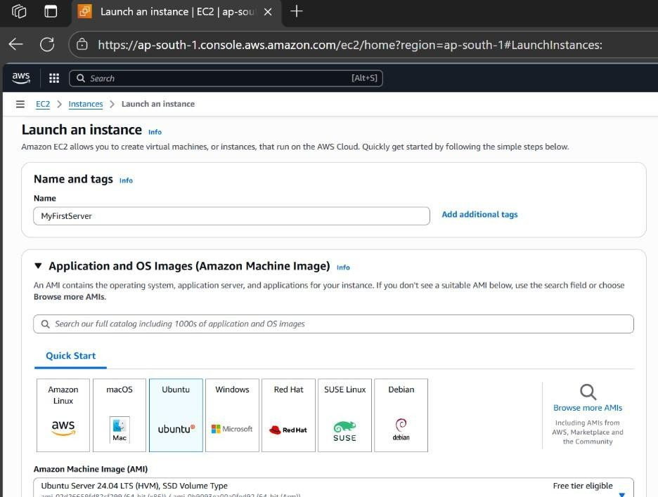
Screenshots:

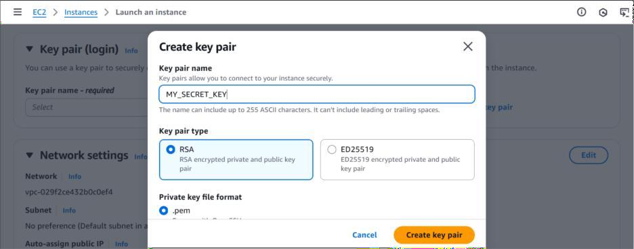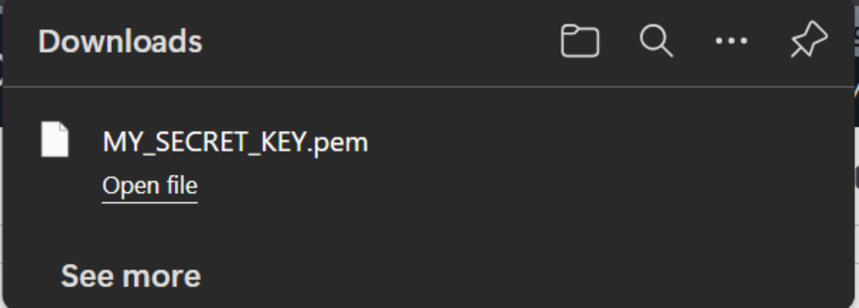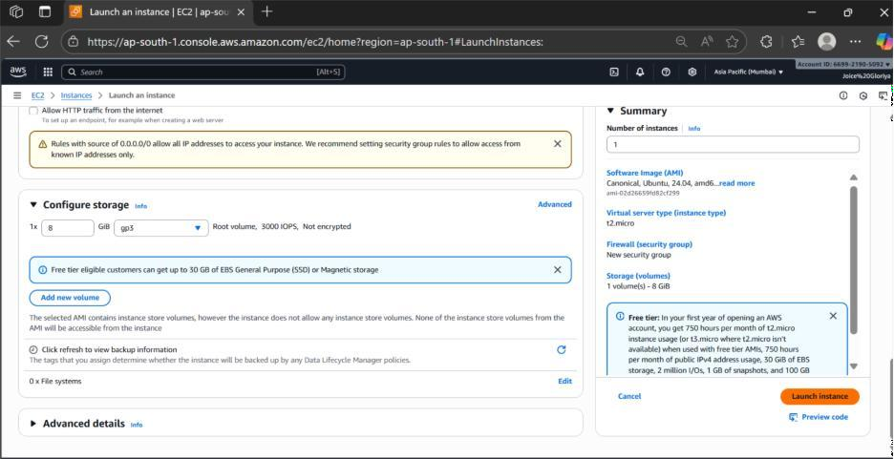

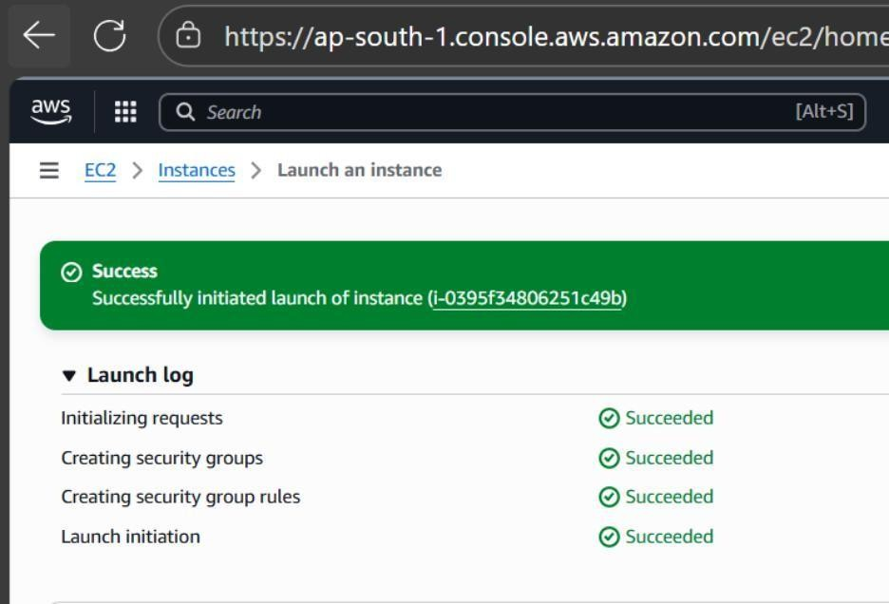
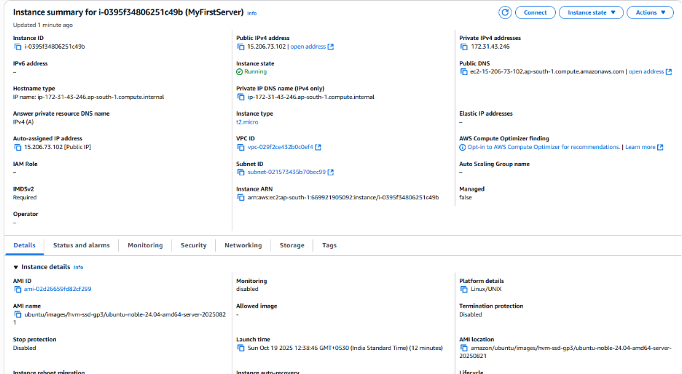

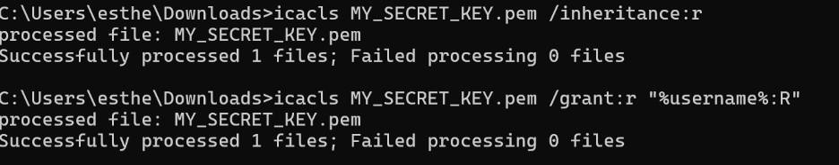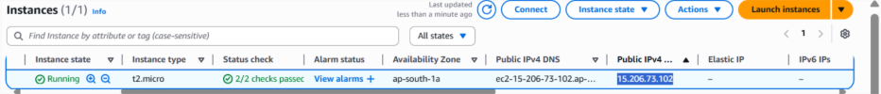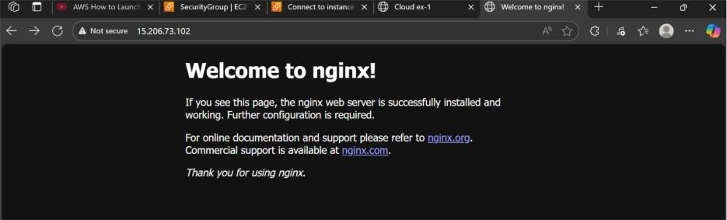

Conclusion:
The experiment successfully demonstrates the process of launching and configuring an AWS EC2 instance using Ubuntu. It includes setting up key-based authentication, configuring network access, and deploying a web server using Nginx. The exercise provides a clear understanding of cloud infrastructure setup and basic deployment on AWS.

Ex No. : 02
Date : 29.08.25

Title: Installation and Exploration of OpenNebula Private Cloud on VirtualBox

Aim

To install and explore the OpenNebula private cloud platform by deploying it on a virtual machine using Oracle VirtualBox, thereby creating a functional private cloud environment for managing virtual resources.

Introduction about the tool

OpenNebula is an open-source cloud management platform designed to manage heterogeneous distributed data center infrastructures. It provides a comprehensive suite to deploy and manage private, public, and hybrid clouds. OpenNebula supports KVM, LXD, VMware, and other hypervisors and offers a flexible front-end for orchestrating virtual machine deployments.
Oracle VirtualBox is a general-purpose virtualizer for hardware virtualization. It allows creating and running multiple operating systems simultaneously on a single physical host, making it ideal for setting up test environments like private clouds on virtual machines.

Purpose and Workflow of the Experiment

The goal of this experiment is to set up a basic private cloud using OpenNebula installed on a VirtualBox VM. The workflow includes:
- Installing VirtualBox and setting up a virtual machine with sufficient resources and network configuration suitable for OpenNebula.

- Downloading and installing OpenNebula front-end and node components on the VM running a supported Linux distribution (e.g., CentOS or Ubuntu).
- Setting up necessary services such as libvirt and enabling the firewall and networking configurations.
- Accessing the OpenNebula Sunstone web interface to manage virtual machines.

- Performing basic explorations like creating VMs, managing virtual networks, and exploring available features of the platform.

Deployment with appropriate code and screenshots

Installation Steps:

- VirtualBox Installation and VM Setup: Install Oracle VirtualBox on the host machine. Create a new VM with recommended settings (at least 4GB RAM, 20GB storage).
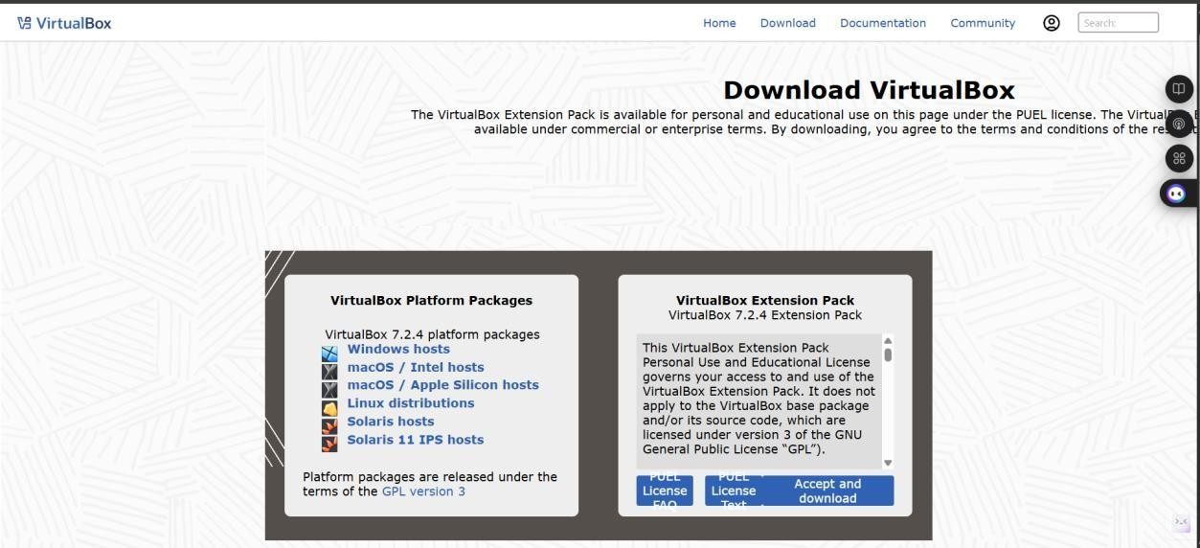
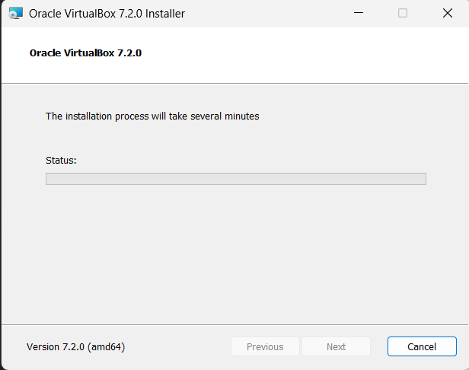
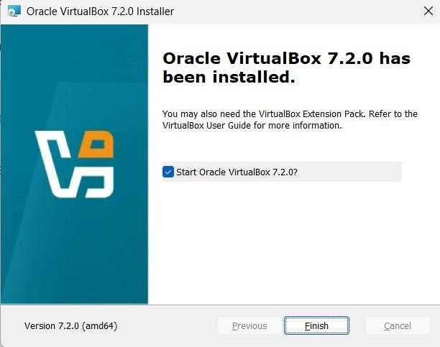

Install Linux OS on VM:
Install a supported Linux OS (Ubuntu 18.04/20.04 LTS or CentOS 7/8).

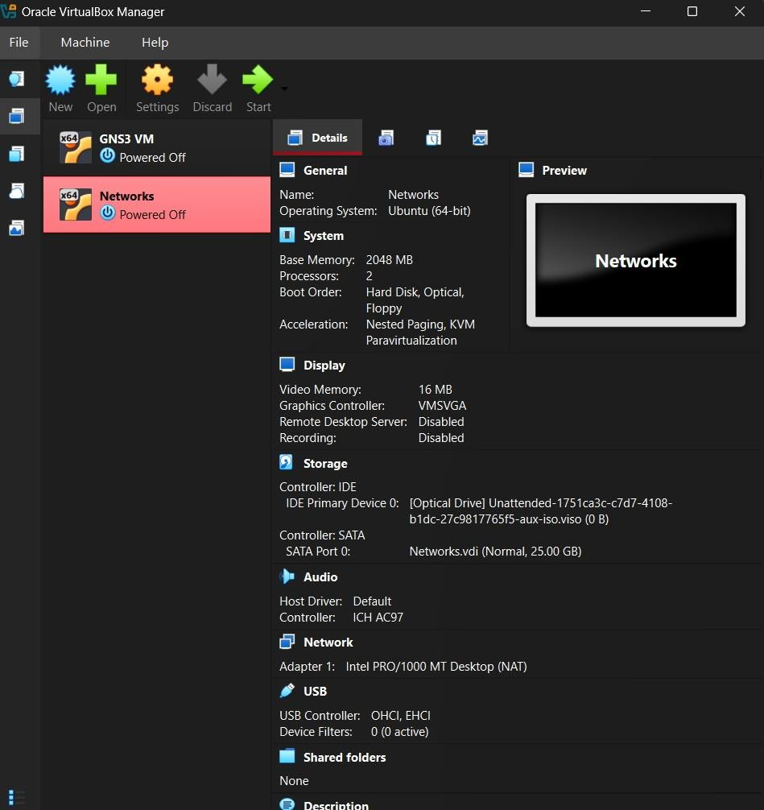

Install OpenNebula components on VM:
Update packages and install required dependencies:

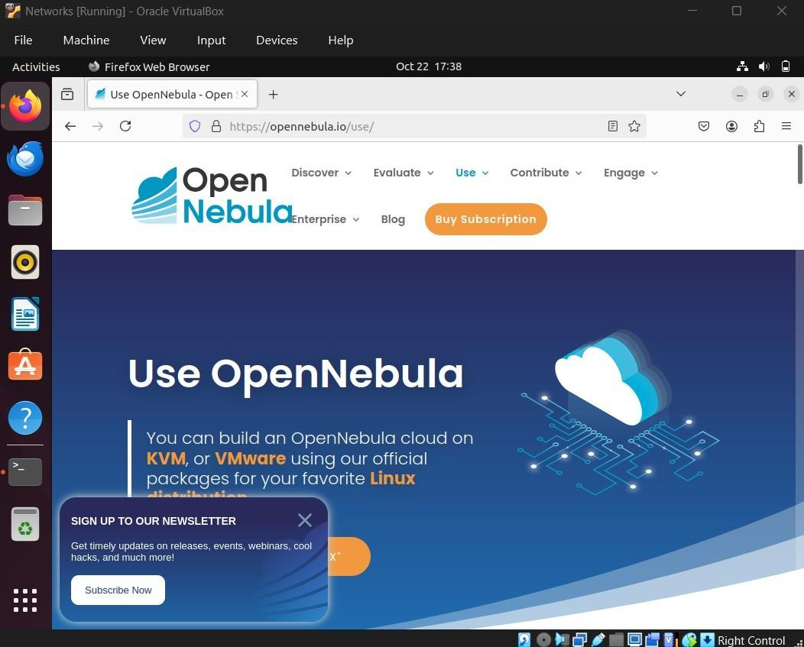
sudo apt-get update
sudo apt-get install opennebula opennebula-sunstone opennebula-node -y

Configure OpenNebula services:
Enable and start services:
sudo systemctl enable opennebula opennebula-sunstone sudo systemctl start opennebula opennebula-sunstone

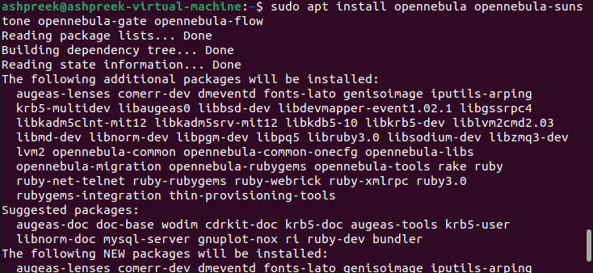

Network Configuration:
Configure virtual networks for VM communication inside OpenNebula. Enable firewall ports if necessary for Sunstone access.
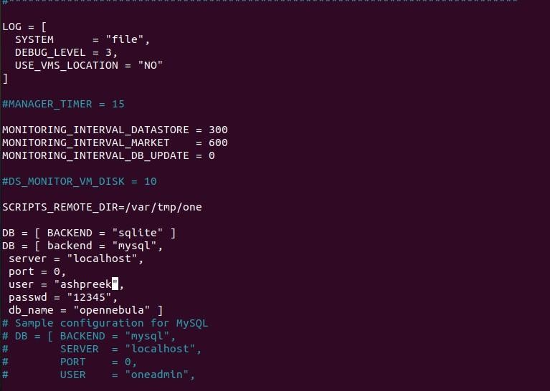

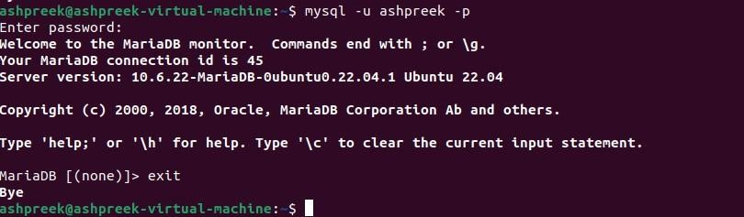

Access OpenNebula Dashboard:
Open browser on host machine and navigate to Sunstone dashboard URL:

Login with default or configured credentials.
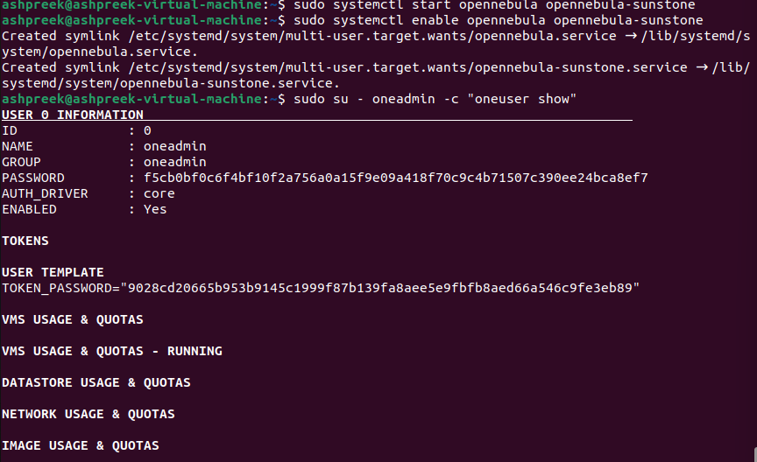

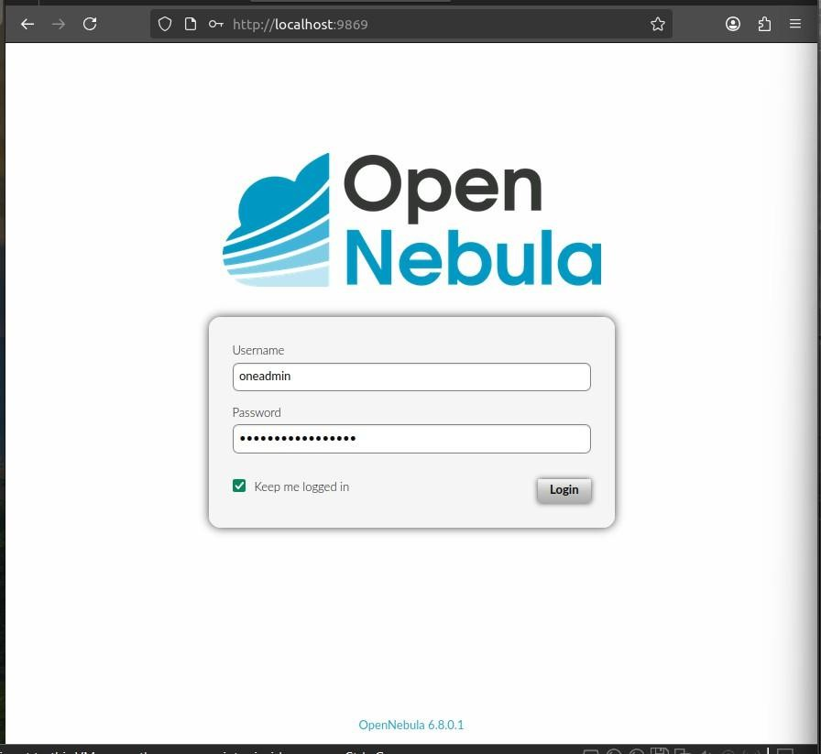
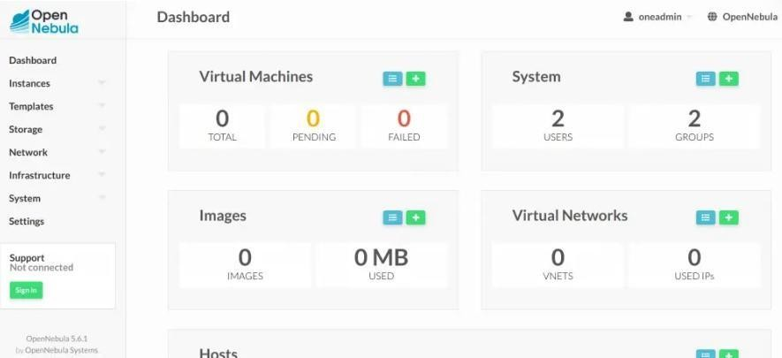

Basic Exploration:
Create sample virtual machines, upload disk images, and manage instances from the dashboard. Explore VM lifecycle operations such as start, stop, suspend, and delete.

Conclusion
The experiment successfully installed and configured OpenNebula private cloud on a VirtualBox VM, providing practical experience with private cloud infrastructure management. The OpenNebula platform's modular components and web interface enabled straightforward deployment and monitoring of virtualized resources. This setup forms the foundation for exploring advanced cloud features like multi-node clusters, storage integration, and hybrid cloud models.

Ex No. : 03
Date : 12.09.25

Title: Installatio n of Google App Engine and Creation of Simple Web Applications using Python/Java

Aim:

To study and install Google App Engine (GAE), configure it for Python or Java environments, and develop simple web applications such as “Hello World” and other basic dynamic web pages using Google’s cloud infrastructure.

Introduction about the Tool:
Google App Engine (GAE) is a Platform as a Service (PaaS) provided by Google Cloud Platform (GCP).
It allows developers to build and host web applications on Google-managed servers, which means developers can focus on writing code rather than worrying about managing servers, scaling infrastructure, or configuring environments.
App Engine provides a fully managed environment, automatic scaling, load balancing, and integrated monitoring.
It supports several programming languages:
- Python
- Java
- Node.js
- PHP
- Go
- Ruby
GAE also provides two environments:

- Standard Environment:
  - Uses a sandbox and supports automatic scaling.

  - Best for lightweight, scalable web apps.
- Flexible Environment:
  - Runs inside Docker containers.
  - Offers more control over system configuration and custom runtimes.

Purpose of the Experiment:
- To understand the process of deploying applications on the cloud.
- To gain knowledge of how App Engine automates deployment and scaling.
- To create and test a simple “Hello World” web app using Python or Java.
- To explore cloud deployment workflows using the Google Cloud SDK.

Step 1: Install Google Cloud SDK
This SDK helps you use GAE from your terminal. Commands (Windows):
- Go to: https://cloud.google.com/sdk/docs/install
- Download the Windows installer.

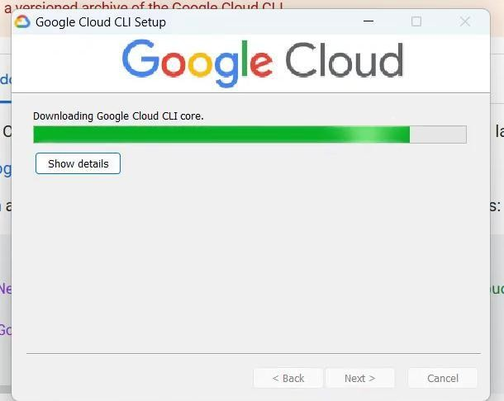
- After installation, open Google Cloud SDK Shell and run:

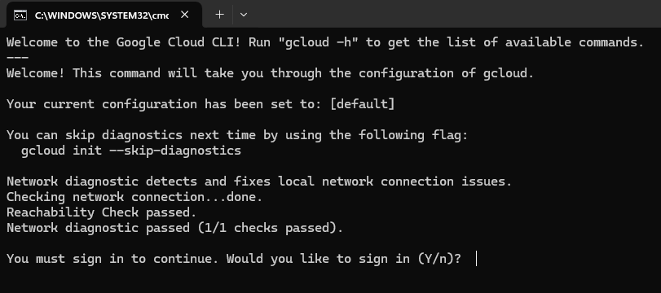
  - Log in with your Google account.
  - Choose your project or create a new one. Step 2: About Payment Verification (Important)
Even though GAE has a Free Tier, Google still requires a payment method to:
  - Verify you’re a real user (not a bot).
  - Allow you to use free resources safely.
  - Step 3: Install App Engine for Python
  - Once the SDK is ready:
Step 4: Create a Simple Python App
Create a folder like myapp/ and inside it, create:
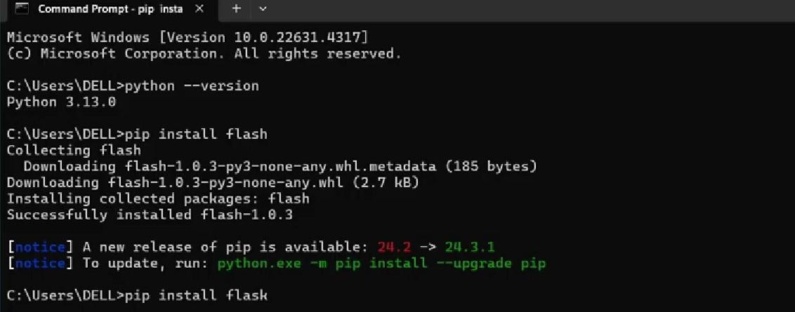

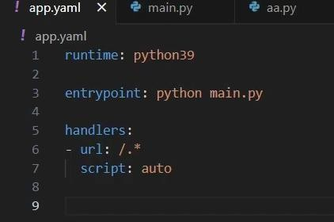

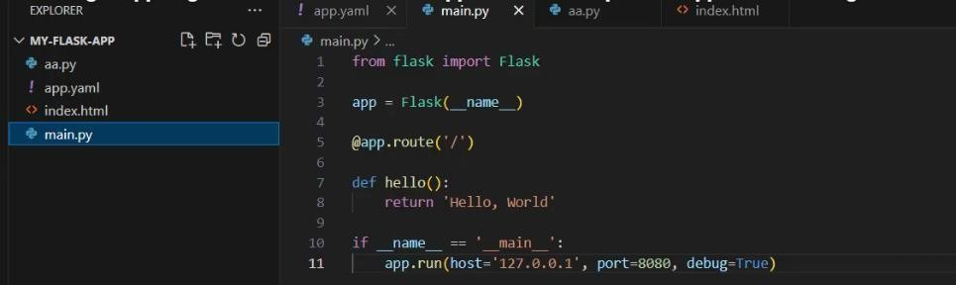
Step 5: Deploy Your App
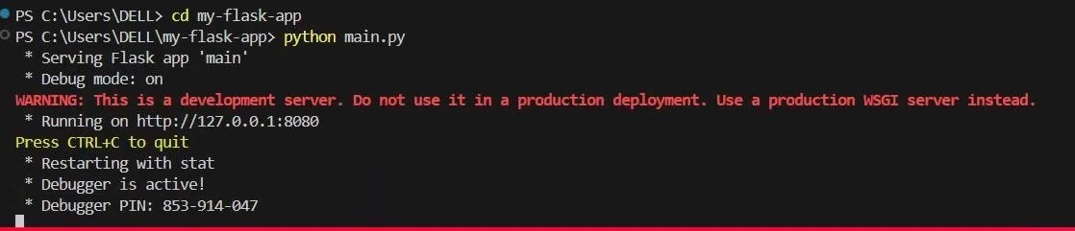
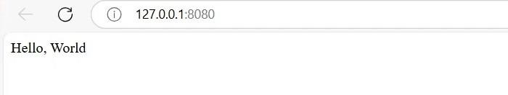

Limitations:
  - Requires billing verification.
  - Limited customization in the standard environment.
  - Cold start latency for some apps.

Conclusion:
In this experiment, we successfully:
  - Installed and configured Google App Engine using Google Cloud SDK.
  - Created and deployed a Hello World web application using Python/Flask (and optionally Java).
  - Understood the workflow of App Engine — from local development to cloud deployment.
  - Observed how App Engine automatically manages deployment, scaling, and hosting.
Thus, this exercise demonstrates how Google App Engine simplifies cloud application hosting by providing a fully managed platform that supports rapid development and easy scalability.

Ex No. : 04
Date : 19.09.25

Title: Deploy a Simple Web Application using Microsoft Azure App Service

Aim:
To deploy a Coffee Shop website on Microsoft Azure using App Service and demonstrate successful hosting of a real-world web application on the cloud.

Introduction about the Tool:
Microsoft Azure App Service is a fully managed platform-as-a-service (PaaS) offering that enables developers to build, deploy, and scale web applications quickly. It supports multiple programming languages like Python, Java, Node.js, .NET, and PHP.
Azure App Service eliminates the need to manage infrastructure, servers, or networking. It automatically handles scaling, load balancing, and security, allowing developers to focus purely on their code. It also integrates seamlessly with Visual Studio Code, GitHub, and Azure CLI for easy deployment.

Purpose of the Experiment:
The main purpose of this experiment is to understand and implement the deployment process of a web application on Microsoft Azure App Service. Through this experiment, a Coffee Shop website (built using HTML, CSS, and JavaScript) is hosted on Azure to make it accessible via a public web URL.
This helps in learning:
- How to host a web application using cloud infrastructure.
- How Azure App Service simplifies deployment without manual server setup.
- How developers can continuously update and manage a live website.
- How cloud platforms ensure scalability, reliability, and security for web applications.
In this experiment, the deployment demonstrates the transition from local development to cloud hosting, showing how modern web applications are managed in real-world environments.

Workflow of the Experiment:
The workflow of deploying the Coffee Shop web page on Azure App Service involves the following steps:
- Project Creation:
  - Develop the Coffee Shop website using HTML, CSS, and JavaScript on a local machine.
  - Test the website locally to ensure proper layout, navigation, and functionality.
- Azure Setup:
  - Log in to the Azure Portal using an active account.
  - Create a new App Service instance under a resource group.
  - Configure settings such as app name, runtime stack, and hosting region.
- Deployment Process:
  - Use either Visual Studio Code with Azure extensions or the ZIP deployment method.
  - Upload or deploy the website files to Azure App Service.
- Verification:
  - Once deployment is complete, obtain the live URL from the App Service overview page.
  - Open the URL in a browser to verify that the Coffee Shop web page is hosted successfully.
- Testing and Maintenance:
  - Test all features and links of the live site.
  - Future updates can be deployed by re-uploading or syncing via GitHub integration.

Deployment steps
Step 1: Prepare Project
Create your Coffee Shop web page locally (example: index.html, style.css, script.js, and images).
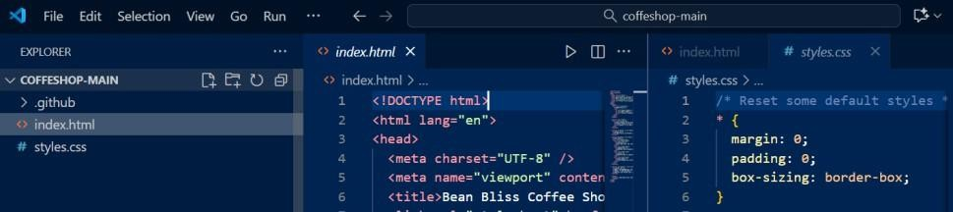
Index.html
<!DOCTYPE html>
<html lang="en">
<head>
<meta charset="UTF-8" />
<meta name="viewport" content="width=device-width, initial-scale=1" />
<title>Bean Bliss Coffee Shop</title>
<link rel="stylesheet" href="styles.css" />
<link href="https://fonts.googleapis.com/css2?family=Poppins:wght@300;600&display=swap" rel="stylesheet" />
</head>
<body>
<header>
<div class="container">
<h1>Bean Bliss</h1>
<nav>
<a href="#about">About</a>
<a href="#menu">Menu</a>
<a href="#contact">Contact</a>
</nav>

</div>
</header>

<section class="hero">
<div class="container">
<h2>Your Perfect Cup of Coffee</h2>
<p>Freshly brewed, artisan coffee made just for you.</p>
<a href="#menu" class="btn">Explore Our Menu</a>
</div>
</section>

<section id="about" class="about container">
<h2>About Us</h2>
<p>At Bean Bliss, we believe coffee is not just a drink, it's an experience. Located in the heart of the city, we source our beans ethically and serve every cup with love.</p>
</section>

<section id="menu" class="menu container">
<h2>Our Menu</h2>
<div class="menu-items">
<div class="menu-item">
<h3>Espresso</h3>
<p>Rich and bold, the classic espresso shot.</p>
</div>
<div class="menu-item">
<h3>Cappuccino</h3>
<p>Espresso with steamed milk and a fluffy foam top.</p>

</div>
<div class="menu-item">
<h3>Latte</h3>
<p>Smooth blend of espresso and steamed milk.</p>
</div>
<div class="menu-item">
<h3>Cold Brew</h3>
<p>Slow-steeped cold coffee for a refreshing taste.</p>
</div>
</div>
</section>

<section id="contact" class="contact container">
<h2>Contact Us</h2>
<p>Email: hello@beanbliss.com</p>
<p>Phone: +1 234 567 890</p>
<p>Address: 123 Coffee Lane, Caffeine City</p>
</section>

<footer>
<p>&copy; 2025 Bean Bliss Coffee Shop. All rights reserved.</p>
</footer>
</body>
</html>
Styles.css
/* Reset some default styles */
* {

margin: 0;
padding: 0;
box-sizing: border-box;
}

body {
font-family: 'Poppins', sans-serif; color: #3b2f2f;
background-color: #f6f1ed; line-height: 1.6;
}

.container {
max-width: 900px; margin: auto; padding: 20px;
}

header {
background-color: #3b2f2f; color: #f6f1ed;
padding: 20px 0; position: sticky; top: 0;
- index: 10;
}

header .container { display: flex;
justify-content: space-between; align-items: center;
}

header h1 {
font-weight: 600; font-size: 1.8rem; letter-spacing: 2px;
}

header nav a { color: #f6f1ed; margin-left: 20px;
text-decoration: none; font-weight: 600; transition: color 0.3s ease;
}

header nav a:hover { color: #c9a66b;
}

.hero {
background: url('https://images.unsplash.com/photo-1509042239860-
f550ce710b93?auto=format&fit=crop&w=1400&q=80') no-repeat center center/cover;

height: 400px; display: flex;
align-items: center; color: #f6f1ed; text-align: center;
}

.hero .container {
background: rgba(59, 47, 47, 0.6); padding: 40px;
border-radius: 10px;
}

.hero h2 {
font-size: 2.5rem; margin-bottom: 10px;
}

.hero p {
font-size: 1.2rem; margin-bottom: 20px;
}

.btn {
background-color: #c9a66b; color: #3b2f2f;
padding: 10px 25px;

text-decoration: none; font-weight: 700; border-radius: 30px;
transition: background-color 0.3s ease;
}

.btn:hover {
background-color: #b48b40;
}

section { margin: 60px 0;
}

h2 {
font-size: 2rem; color: #3b2f2f; margin-bottom: 20px;
border-bottom: 3px solid #c9a66b; display: inline-block;
padding-bottom: 5px;
}

.menu-items { display: grid;
grid-template-columns: repeat(auto-fit, minmax(200px, 1fr)); gap: 30px;

}

.menu-item {
background-color: #f0e8d0; padding: 20px;
border-radius: 10px;
box-shadow: 2px 4px 10px rgba(0,0,0,0.1); transition: transform 0.3s ease;
}

.menu-item:hover { transform: scale(1.05);
}

.menu-item h3 { margin-bottom: 10px; color: #7a5a0c;
}

footer {
text-align: center; padding: 20px 0;
background-color: #3b2f2f; color: #f6f1ed;
margin-top: 60px; font-size: 0.9rem;
}

Step 2: Test Locally
Open index.html in your browser and verify that the website layout, images, and navigation work correctly.
Step 3: Create Web App on Azure Portal
  - Login to https://portal.azure.com
  - Search Static web app → Create.
  - Fill details:
    - App name: acoffeeshop
    - Publish: Code
    - Runtime stack: HTML/Node.js (if static, use “Static Web App” or choose Python if using Flask backend)
    - Region: India South
  - Click Review + Create → Create

- Deployment Configuration Options in Azure Static Web App

When you create a Static Web App in Azure Portal, under “Deployment Details”, Azure asks you
to choose how you’ll deploy your site. You’ll see two options:
GitHub
Other (Deployment Token
Best for: Continuous Deployment (auto-updates when you push to GitHub)
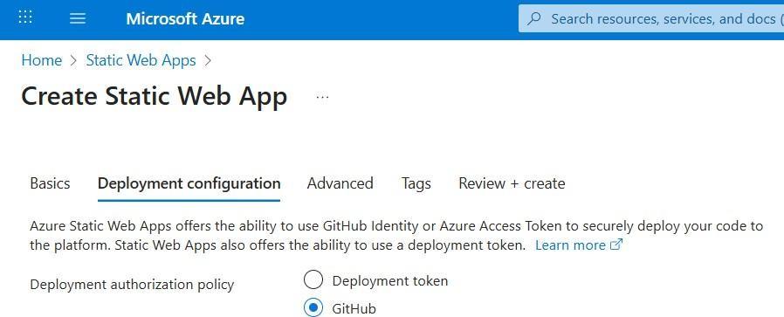

How it works:
- You connect your GitHub account during Static Web App creation.
- Choose your repo and branch (like main).
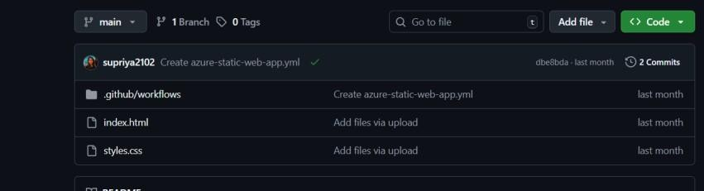
- Azure automatically sets up a GitHub Action workflow.
- Every time you update your code and push it to GitHub → Azure redeploys automatically. Next choose your region :

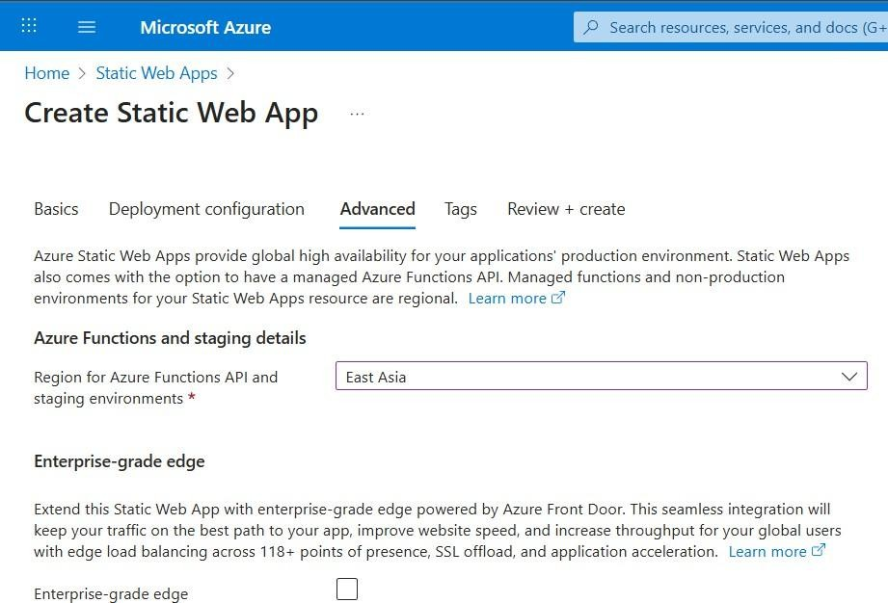

- Review + Create
This is the final review step before Azure deploys your app.
It shows a summary of all configurations you’ve chosen:
- Resource Group name,App name,Deployment method (Token or GitHub),Region

Go to Your Web App Resource
- Once Azure shows “Deployment Succeeded”, click Go to Resource.
- You’ll land on your Static Web App overview page.

Here you can see:

- Status: Running
- Region, Resource Group, Plan type

Open Your Live Website by clicking “visit your site”
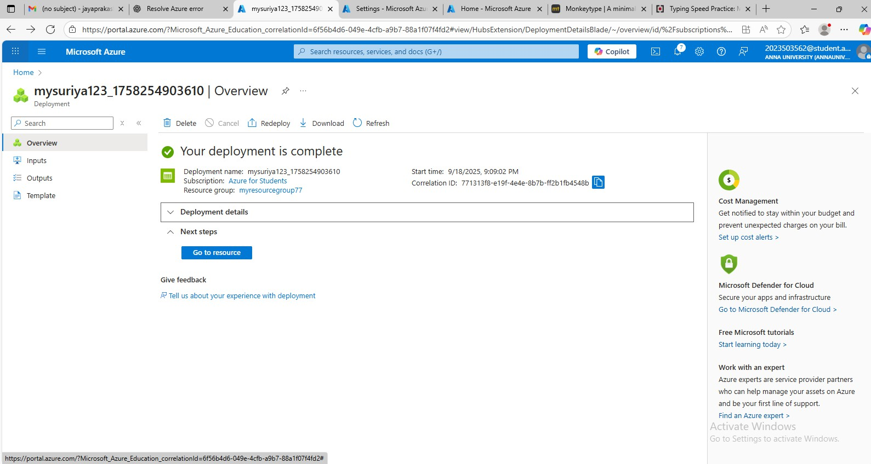

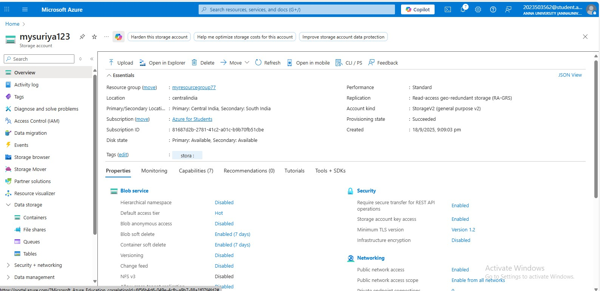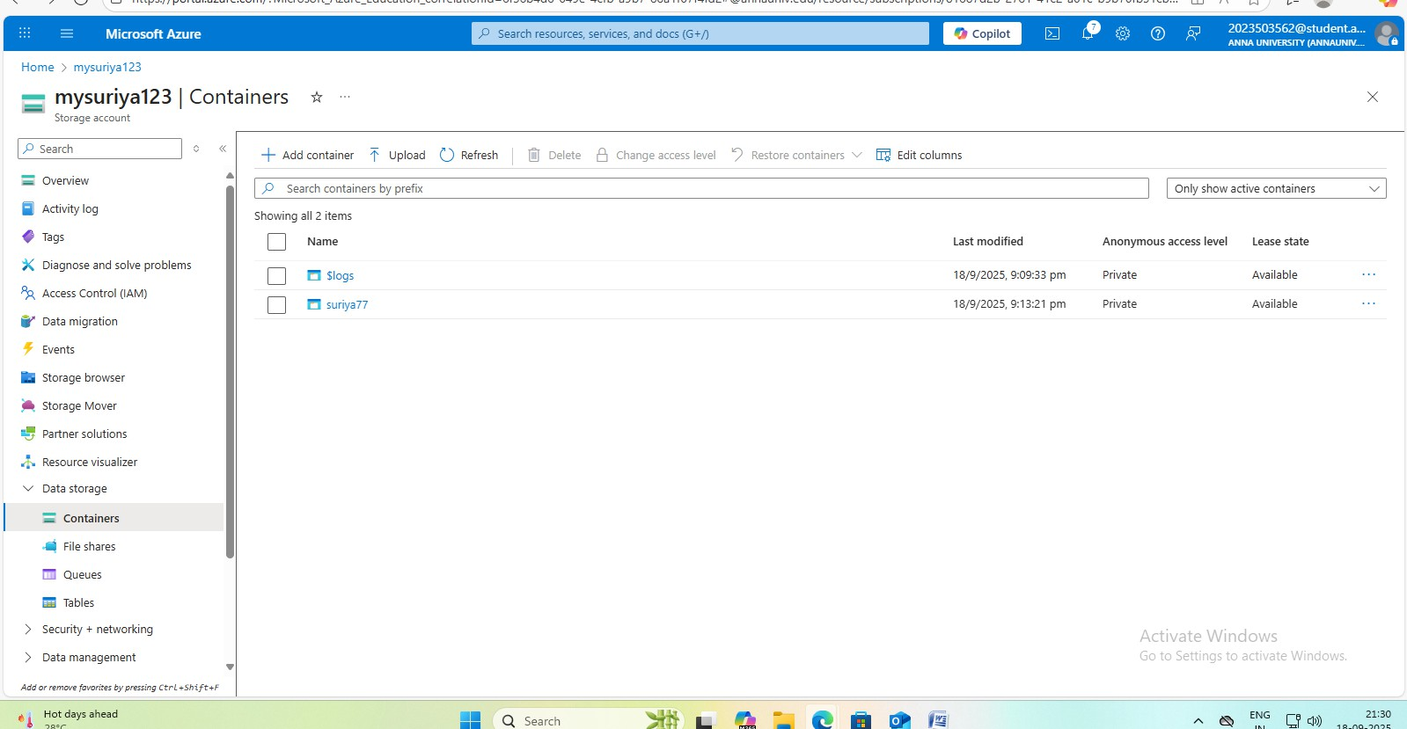

Conclusion:
Thus, the Coffee Shop web application was successfully deployed on Microsoft Azure App Service.
The experiment demonstrated the process of deploying a front-end web project to the cloud, verifying accessibility, and understanding cloud hosting principles. Azure App Service simplified deployment by handling server configuration and hosting automatically

Ex No.: 5
Date: 26.09.25

Title: Exploration of Docker

Aim:
To study and explore Docker, install it on a Linux environment (WSL2 Ubuntu), and demonstrate containerization using basic Docker commands.

Introduction about the Tool:
Docker is an open-source containerization platform that automates the deployment of applications inside lightweight, portable containers. These containers bundle applications with their dependencies, enabling consistent execution across environments. Docker uses Linux kernel features such as namespaces and cgroups to provide isolated containers that share the host OS without the overhead of full virtual machines. Docker Hub serves as a public registry for container images, facilitating easy sharing and reuse.

Purpose of the Experiment:
- Install Docker on WSL2 Ubuntu.
- Learn core Docker components: Docker Engine, Images, Containers, and Docker Hub.
- Execute fundamental Docker commands such as run, pull, build, and ps.
- Build and run a custom Docker image running a simple Python HTTP server.

Procedure:

Step 1: Verify Linux Environment
Open Linux terminal (Ubuntu WSL2). Run:
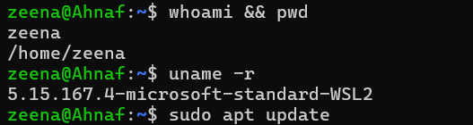

Step 2: Install Docker
Update packages and install Docker: bash
sudo apt update
sudo apt install docker.io -y
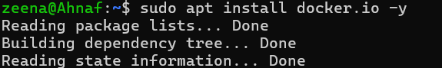
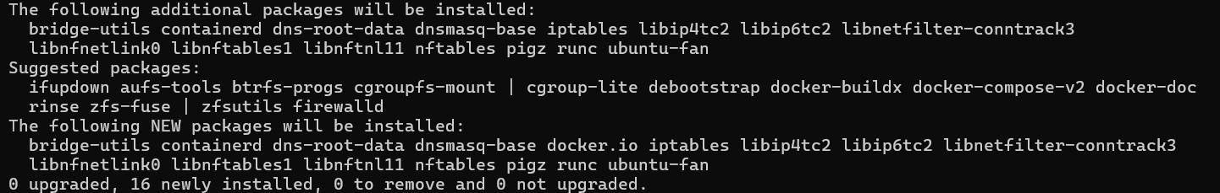

sudo systemctl start docker sudo systemctl enable docker sudo systemctl status docker
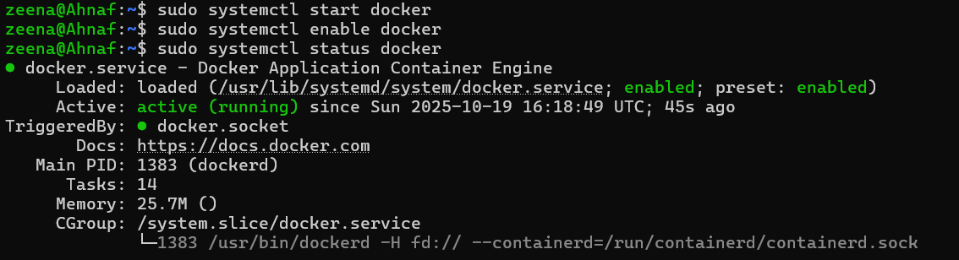
Step 3: Verify Docker Installation Check Docker version and health: docker version
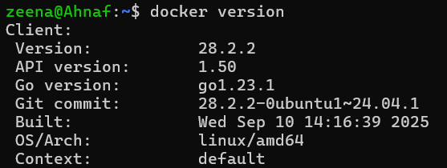

docker info
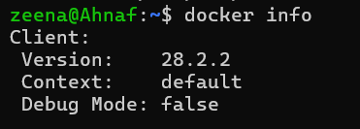

Step 4: Run Hello World Container
Run the test container to verify:
sudo docker run hello-world
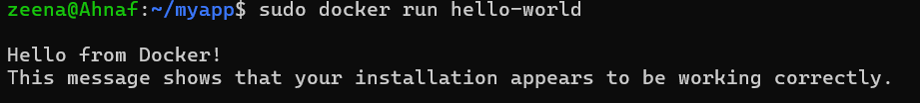
Screenshot showed Docker pulled image and ran successfully.

Step 5: Explore Docker Images and Containers
List images and all containers:
sudo docker images sudo docker ps -a
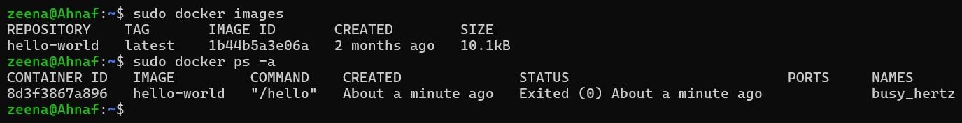
Step 6: Run Interactive Ubuntu Container Start an interactive container and verify: sudo docker run -it ubuntu bash

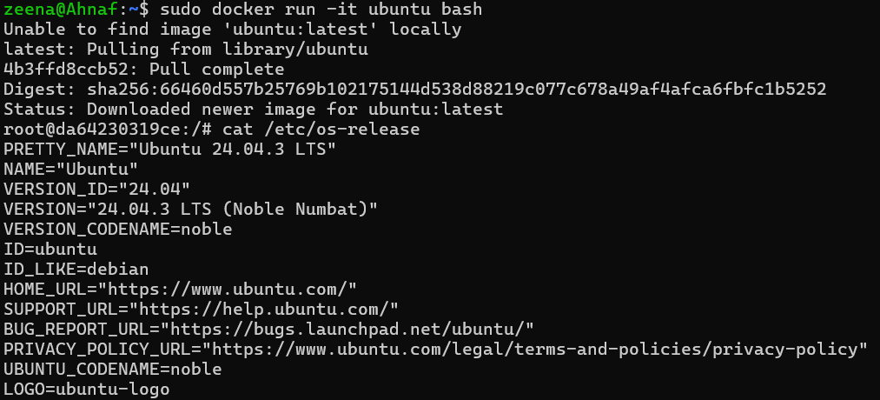
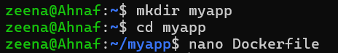
exit

Step 7: Create Custom Docker Image
Create project folder and Dockerfile:
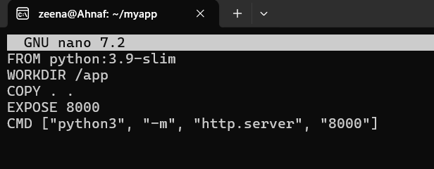

Step 8: Build and Run Custom Container
Build image and run container: sudo docker build -t myapp-image .

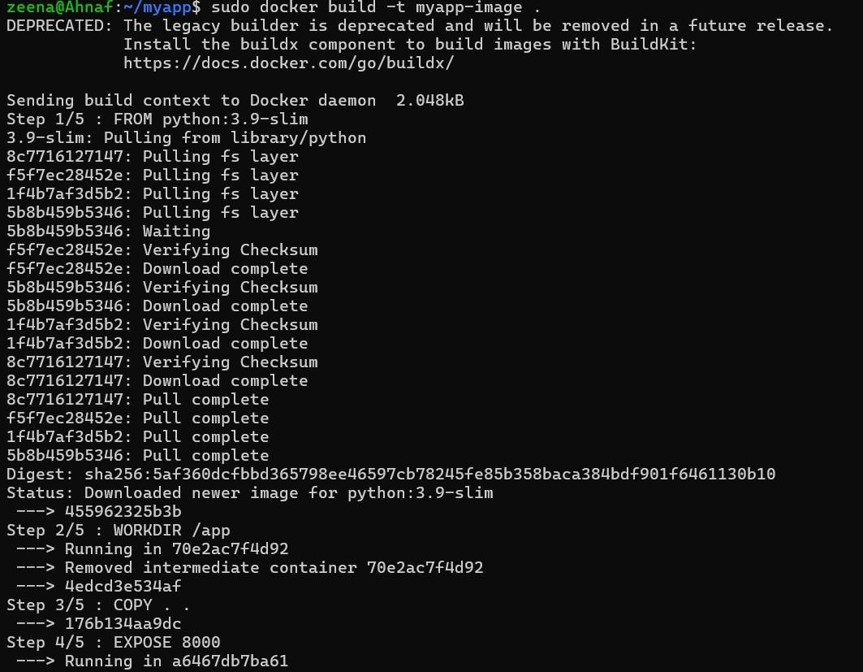
sudo docker run -d -p 8000:8000 myapp-image
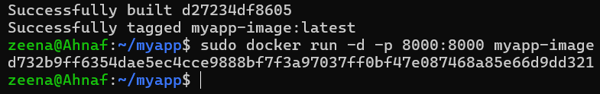

Step 9: Test Containerized App
Open browser at http://localhost:8000, verified running Python HTTP web server.
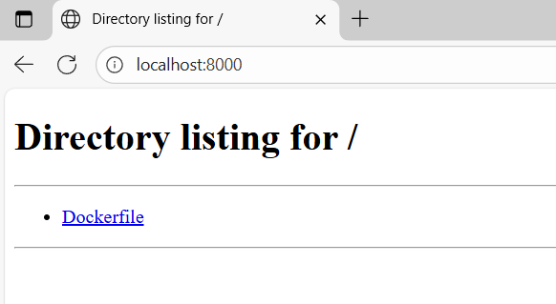

Step 10: Manage Containers
Stop and remove container:
sudo docker ps
sudo docker stop <d732b9ff6354dae5ec4cce9888bf7f3a97037ff0bf47e087468a85e66d9dd321 > sudo docker rm <d732b9ff6354dae5ec4cce9888bf7f3a97037ff0bf47e087468a85e66d9dd321 >

Result:
Docker was successfully installed and configured on WSL2 Ubuntu. Basic Docker containers such as hello-world and ubuntu ran correctly. A custom Docker image was created and deployed a simple Python HTTP server, accessed successfully at http://localhost:8000. The experiment demonstrated Docker’s core functionalities of image building, container runtime, and port mapping.

Limitations:
Docker requires root permissions or Docker group configuration. Performance depends on host OS kernel and resources. GUI applications are not natively supported without extra configuration. Network configurations can be complex for multi-container deployments.

Conclusion:
This experiment showed how Docker enables rapid, consistent application deployment across systems using lightweight containers. It highlighted key Docker concepts: images, containers, Docker Hub, and commands to build, run, and manage containers. Mastering Docker is essential for modern cloud-native application development and deployment.

Ex No.: 06
Date: 10.10.25

Title: Simulating Cloud Task Scheduling and Resource Allocation in Google Colab

Aim:
To simulate multiple cloud scheduling algorithms (FCFS, Priority, Round Robin) and visualize resource allocation using Python in Google Colab.

Introduction:
Cloud data centers rely on various scheduling algorithms and resource allocation strategies to maximize efficiency—assigning incoming jobs to available VMs/servers to reduce wait time and improve system utilization. In this experiment, we use Python code in Google Colab to simulate both traditional task scheduling and explicit VM allocation.

Purpose of the Experiment:
- Define a set of incoming cloud tasks, including job details, arrival times, burst times, and priorities.
- Simulate FCFS, Priority, and Round Robin scheduling policies.
- Allocate and track tasks on multiple VMs to mimic cloud resource distribution.
- Visualize and interpret results with Gantt charts for all algorithms and setups.

Procedure:

Step 1: Open Google Colab
- Navigate to https://colab.research.google.com and start a new notebook.

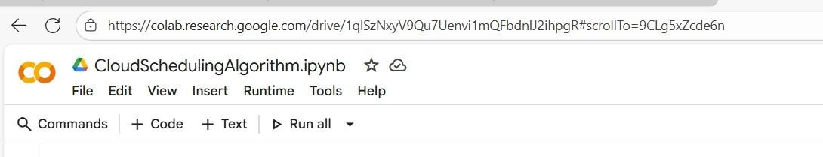

Step 2: Define Tasks for Simulation

python
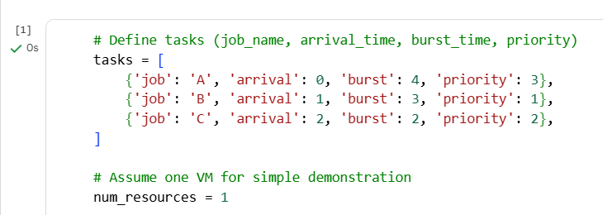

Step 3: FCFS Scheduling Algorithm (Single VM)

Python
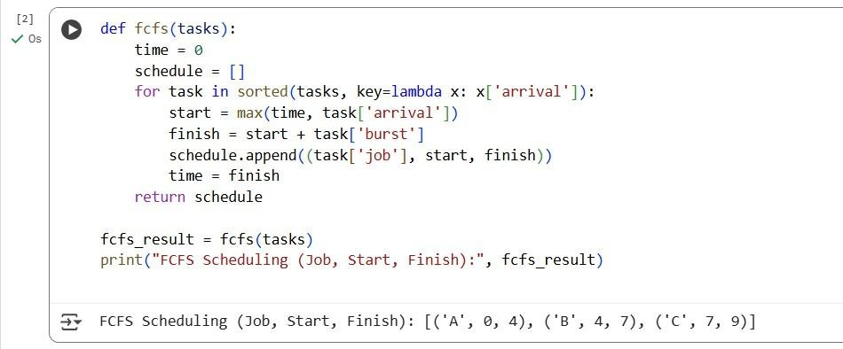

Step 4: Priority Scheduling Algorithm
Python
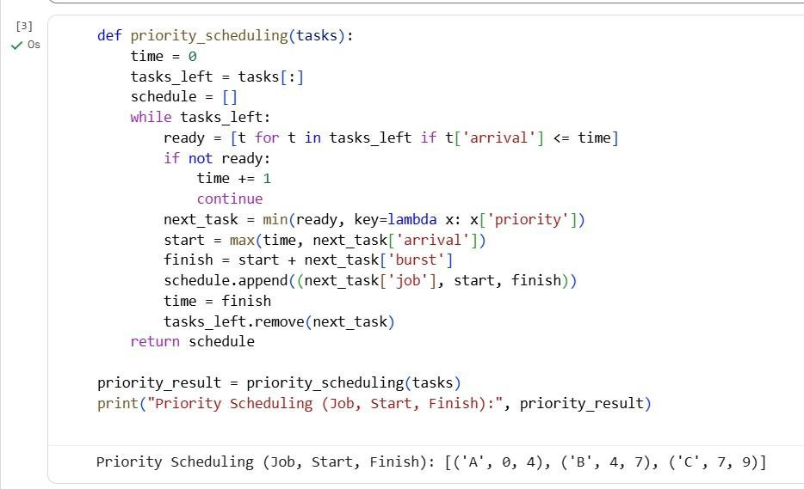

Step 5: Round Robin Scheduling Algorithm
Python
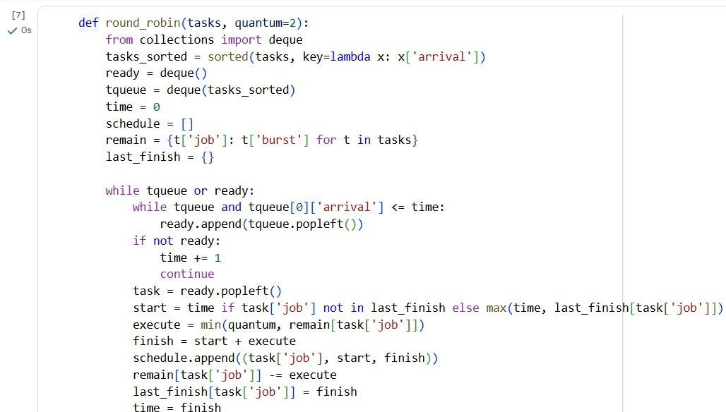

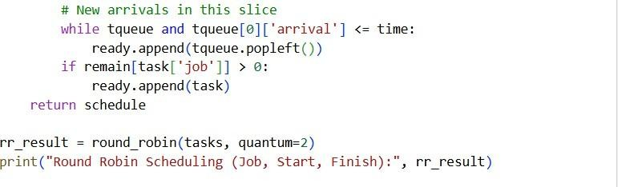
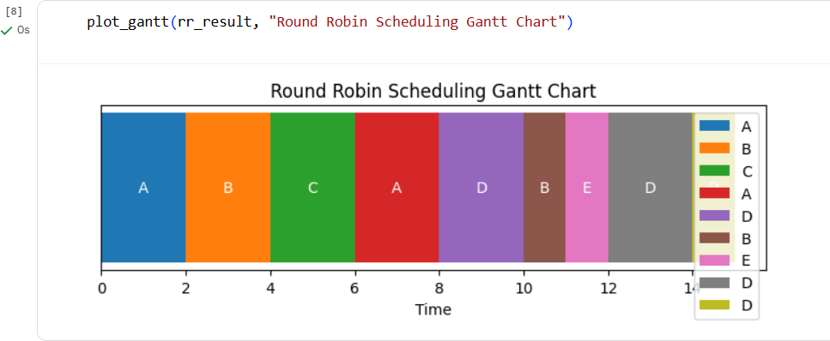

Step 6: Multi-Resource (VM) FCFS Scheduling (Resource Allocation)
python
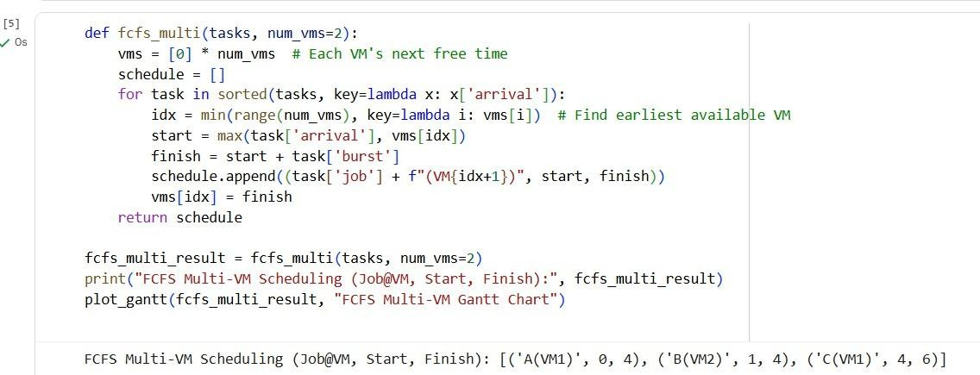

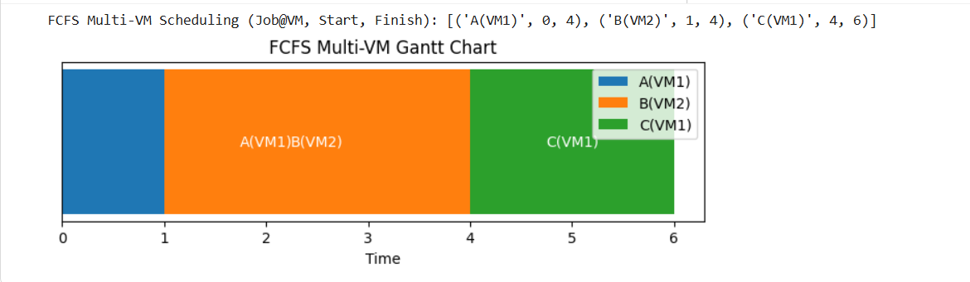

Step 7: Gantt Chart Visualization
python
import matplotlib.pyplot as plt

def plot_gantt(schedule, title): plt.figure(figsize=(10,2)) y_pos = 1
seen = {}
for (job, start, finish) in schedule:
base_job = job.split('(')[1][:-1] if '(' in job else job y = seen.setdefault(base_job, y_pos)
plt.barh(y, finish - start, left=start, label=job) plt.text((start+finish)/2, y, job, va='center', ha='center', color='white') y_pos += 1
plt.title(title) plt.xlabel('Time') plt.legend() plt.yticks([]) plt.show()

plot_gantt(fcfs_result, "FCFS Scheduling Gantt Chart")

plot_gantt(priority_result, "Priority Scheduling Gantt Chart") plot_gantt(rr_result, "Round Robin Scheduling Gantt Chart")
plot_gantt(fcfs_multi_result, "FCFS Multi-VM Resource Allocation Gantt Chart")
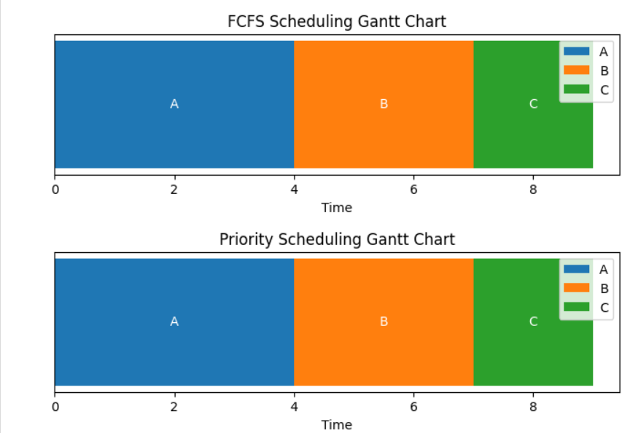


Result:
Cloud task scheduling was simulated for multiple algorithms and resource allocation scenarios in Google Colab. The experiment showed clearly how jobs are mapped to VMs under different strategies, and the generated Gantt charts illustrate both scheduling and resource allocation visually.

Conclusion:
The use of multiple VMs for task scheduling shows improved system throughput and reduced idle time when compared to single-resource models. Resource allocation and scheduling policy both play critical roles in optimizing cloud performance. These simulations help visualize how cloud platforms make real-time decisions to allocate their computational resources efficiently.

Mini Project: Cloud Vault project

Abstract
The Cloud Vault project is a secure cloud-based file management and storage system that enables users to upload, organize, and access their data anytime, anywhere. The system leverages the Supabase backend for authentication, database management, and storage handling, ensuring both scalability and reliability. The application is built using Flask for backend logic and integrates seamlessly with cloud APIs to store and retrieve files. Its modular design allows easy management of tasks such as file uploads, metadata storage, user authentication, and data retrieval. The Cloud Vault system thus provides a user-friendly, efficient, and secure environment for managing digital assets online.

Introduction
In today’s digital era, managing and accessing data securely across multiple devices is essential. Cloud Vault aims to provide an effective solution by integrating a cloud-based file storage system using Supabase and Flask.
The platform allows users to create accounts, upload files, and manage their data in a structured and secure manner. Supabase, an open-source Firebase alternative, is utilized for authentication, storage, and database operations, making the system highly reliable and easy to scale.
This project emphasizes simplicity in design and security in data handling, ensuring that users’ files and information remain private and accessible only to authorized users.

1. Task Input & Creation
- The user initiates the process by creating a new storage task — such as uploading a file, creating a folder, or saving metadata.
- A simple input form collects the file name, category, and description.
- On clicking “Upload” or submitting the form, the request is validated (checking file type, size, and duplicates).
- Once validated, the file and its associated metadata (user ID, upload date, file type, and storage path) are sent to the Flask backend and stored in the Supabase database.
- The upload task is assigned a unique ID and an initial status (“Pending” or “Uploaded”).

2. File Upload & Storage
- The Flask backend receives the file through a secure POST request.
- Using Supabase Storage API, the file is uploaded to the user’s dedicated storage bucket.
- Metadata such as filename, owner, timestamp, and public/private access status are recorded in the Supabase database.
- If any upload error occurs (e.g., invalid file or network issue), appropriate error messages are displayed and logged.

3. File Retrieval & Listing
- The system dynamically fetches all user files from the Supabase database and renders them as a list or grid.
- Each file entry displays its name, upload date, file size, and access status (public/private).
- Files are clickable, allowing users to download, preview, or delete them directly from the UI.
- Flask handles the retrieval routes, while Supabase provides the signed URL for secure access.

4. Access Control & Authentication
- Supabase authentication manages user signup, login, and session handling.
- Only authenticated users can upload or access their stored files.
- Flask verifies each request using the user’s access token before performing any file operation.
- Admin privileges (if enabled) allow file moderation, storage usage tracking, and analytics.

5. File Deletion & Update
- Users can delete files using the “Delete” button next to each file entry.
- Upon confirmation, Flask triggers a Supabase API call to remove both the file and its record from the database.
- Similarly, users can rename files or update metadata (like category or description).
- These updates are instantly reflected in the database and the UI through asynchronous requests.

6. Persistence & Dashboard
- All file information and user preferences (such as view type or sort order) are stored persistently in Supabase.
- On every login, Flask loads the user’s existing files and displays them on the dashboard.
- This ensures data consistency and continuity across sessions and devices.

Implementation
Key components of implementation include:
- Frontend (HTML/CSS/JavaScript)
  - index.html: Provides the main interface — upload form, file listing area, and action buttons (Upload, Delete, Download).
  - style.css: Defines responsive design, card-based layout for files, hover effects, and modern UI styling.
  - script.js: Handles frontend logic — form submission, API calls to Flask routes, dynamic DOM updates, and notifications.
- Backend (Flask)
  - Manages routes for /upload, /files, /download, /delete.
  - Integrates with Supabase Python SDK using environment variables (SUPABASE_URL, SUPABASE_KEY).
  - Validates file uploads, interacts with Supabase Storage and Database, and returns JSON responses to the frontend.
- Database (Supabase)
  - Stores user profiles, file metadata (filename, type, size, timestamp, owner ID).
  - Handles authentication and session persistence.
  - Supabase Storage module is used for actual file storage and retrieval.

Results
The Cloud Vault web application successfully achieved its goal of providing a secure and easy-to-use cloud storage solution.
Key outcomes include:
- Users can upload, view, download, and delete files in real time.
- All data is securely stored in Supabase and accessible across sessions.
- User authentication ensures data privacy and access control.
- The interface is clean, responsive, and supports mobile devices.
- Backend integration with Flask makes the system extendable for future modules such as analytics and sharing.

Conclusion
The Cloud Vault project demonstrates the integration of Flask and Supabase to create a complete cloud-based storage system.
It highlights key web development skills — from frontend design and API interaction to backend management and database integration.
The system offers a user-friendly UI, real-time updates, and secure data handling.
Future enhancements can include file sharing via link, storage usage analytics, folder structuring, and integration with AI-based search or tagging.

Login page

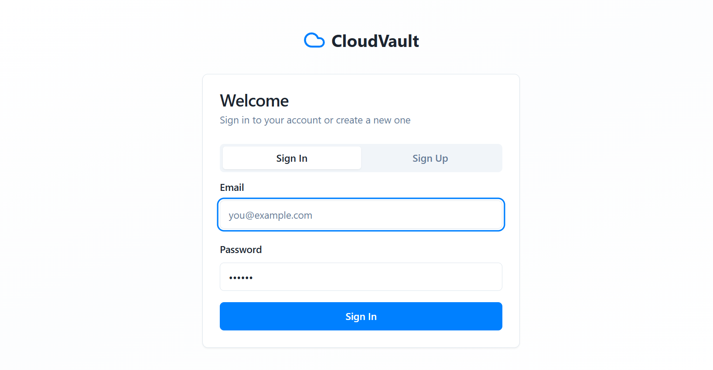

After login home page
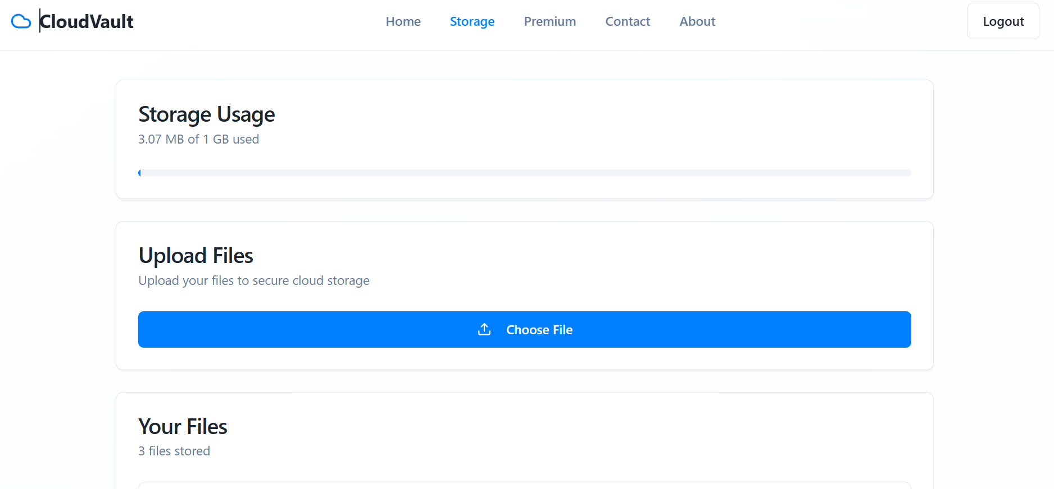

Now select the file to store
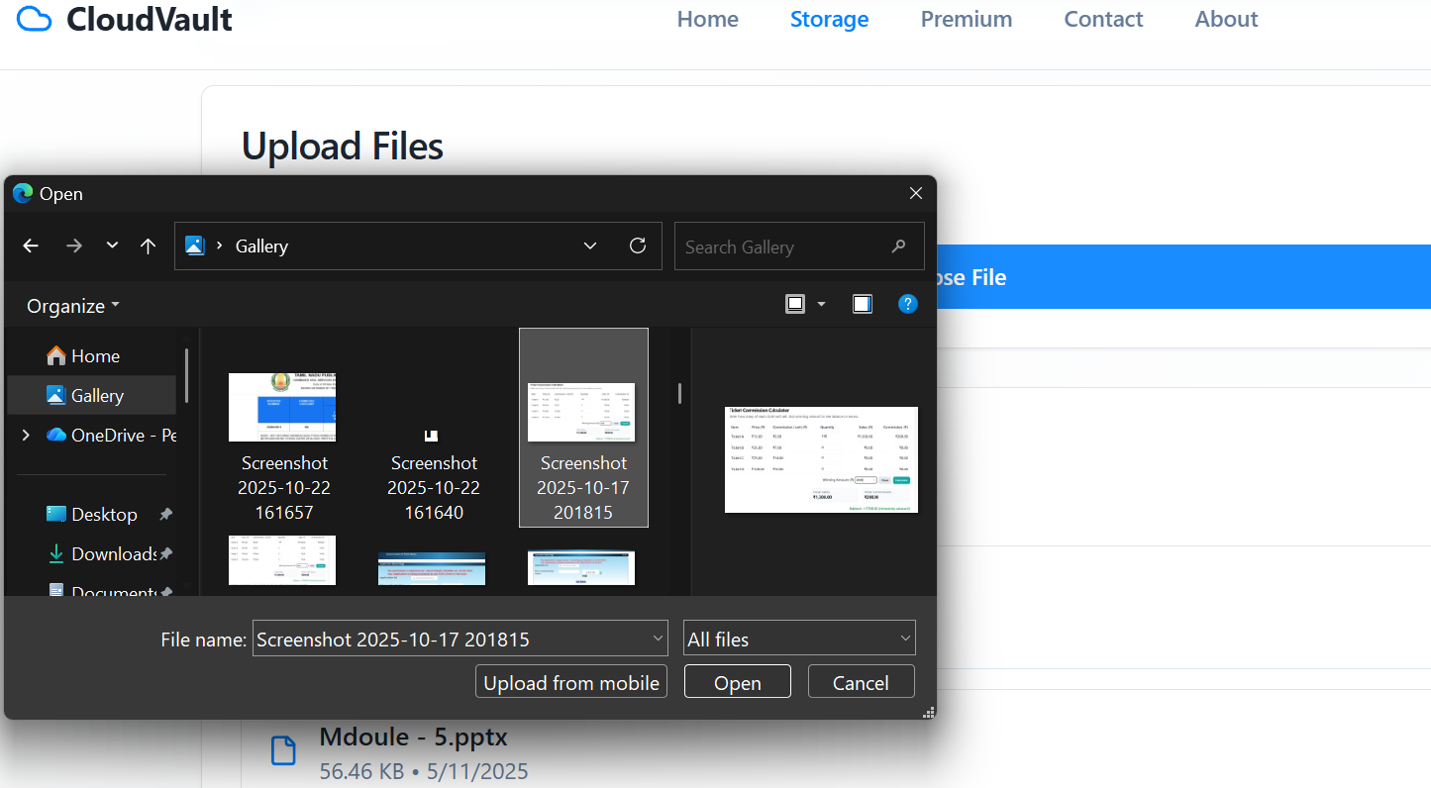

After selecting processing your file
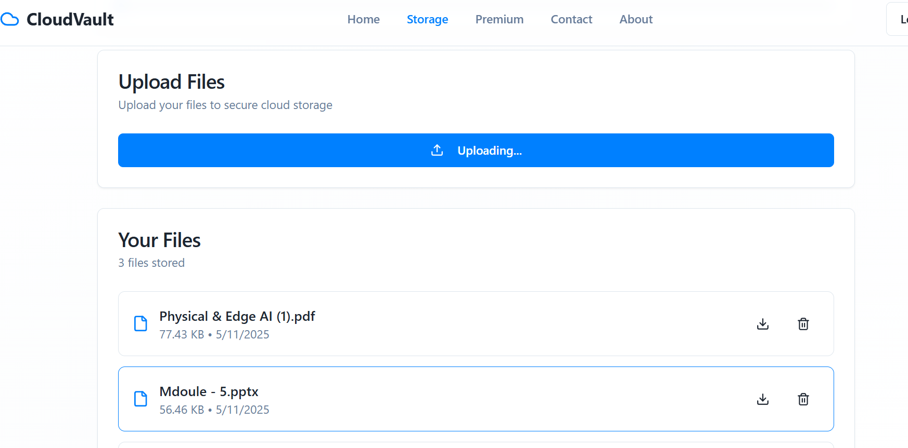

File will be uploaded
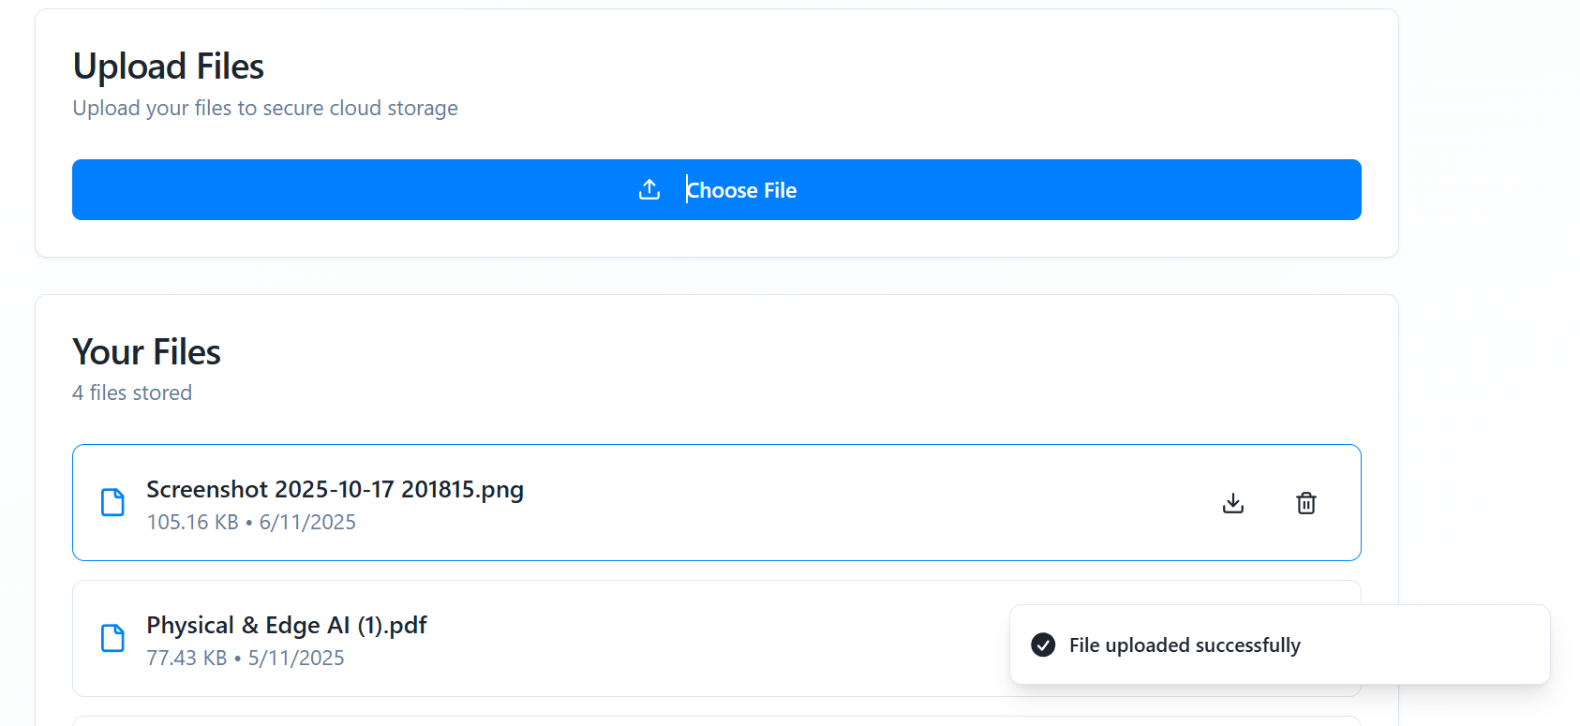

Backend

Two tables are created to store data in supabase
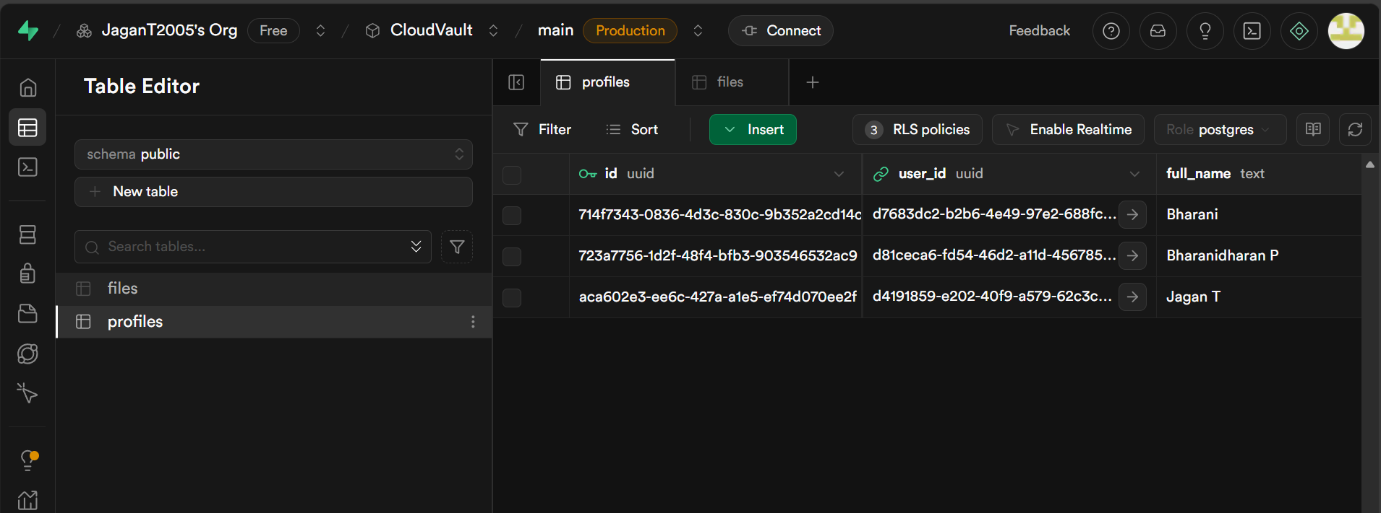

Profiles will store the login information



Files will store the uploaded file infomation
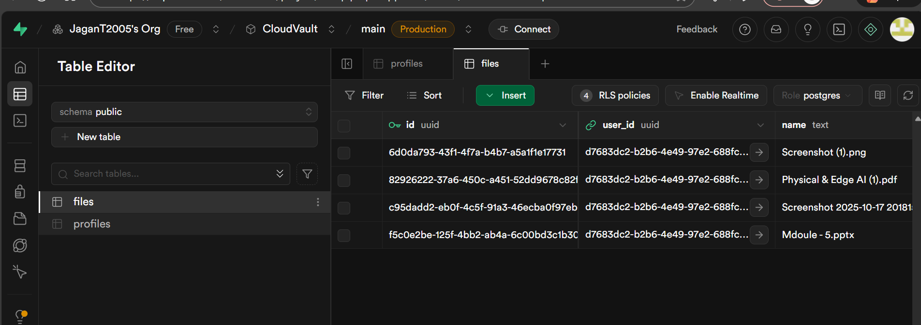

Result :
The Cloud Vault project demonstrates the integration of Flask and Supabase to create a complete cloud-based storage system.
It highlights key web development skills — from frontend design and API interaction to backend management and database integration.
The system offers a user-friendly UI, real-time updates, and secure data handling.
Future enhancements can include file sharing via link, storage usage analytics, folder structuring, and integration with AI-based search or tagging.

